**Report on Updates Of SIH PS: Digital Policing**

Sensors :

1.Acclereometer: linear Acceleration

2.Gyroscope: Radial Acceleration Angular Velocity, Circular motion, Turning of the Body

3.Heart Rate

4.Barometer:Pressure

5.Proximity: meausres distances upto 5cm

6.Ambient light : Intensity of light (Sir We can use ambient light if mobile not kept in pocket or bag that whether he is in dark Areas because theft , murders take place in lonely dark areas Sir kindly suggest recommendations).

**Our Danger Cond. Basically includes Running with great speed and shivering of hands(sensors can count this only if mobile on hands) and Falling Before running**

**Loudness Shouting Common Reflex of Danger.**

**ISSUES**

1. Cannot Differentiate between run and Danger

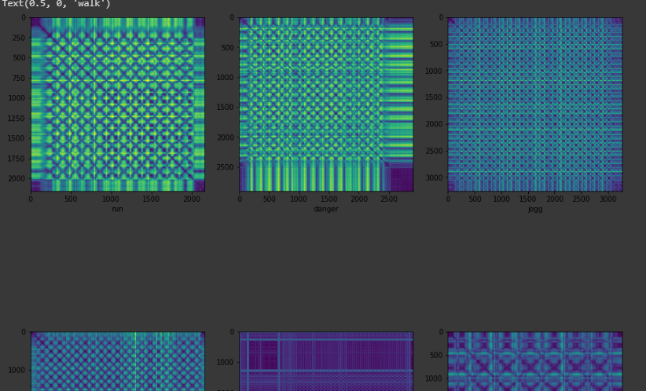

2. Using Some other algorithm to handle LSTM sensors data with more Accuracy

3. Specific Input size of the time series data to feed to model for classification and Specific Output size.

4. Preprocessing of time series data in Java because we are using python libraries for Recurrence Plot, Scaling and Rescaling.

5.Positions of mobile in diff cond. whether bag or left hand right hand or pocket.

**Condition of Abnormalities:**

**1. Running Apart normal running time in Days Schedule need to fix the time-> loudness -> Run= Danger**

**2.Loudness Detected First trigger ->Fall Detected or Not if no then even okay-> Run**

**3. Fall Detected ->loudness -> Danger(Since Unable to handle to run)**

**Very Big Issue Human Positions Of Keeping Phones:**

**This section requires your serious help**

Right Hand (Mostly)

Left Hand(rarely)

Pocket( often )cannot detect shivering in this case then how to Detect

Hand Bags and pockets (Womens).

**Activities :**

**Danger**

**Fall**

**run**

**jogg**

**sit**

**standexercise**

please suggest some more recommendations to add Activities to improve model accuracy and distinguishing ability of danger

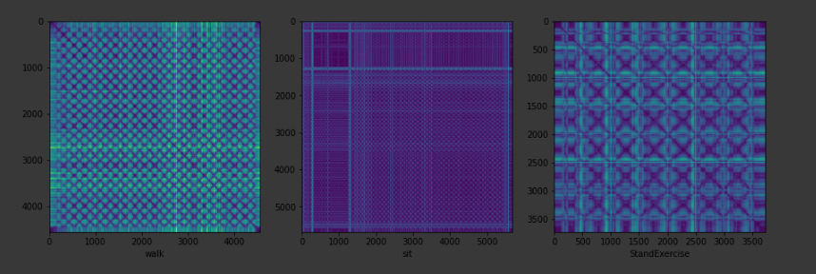

walking Recurrence plot (see below)

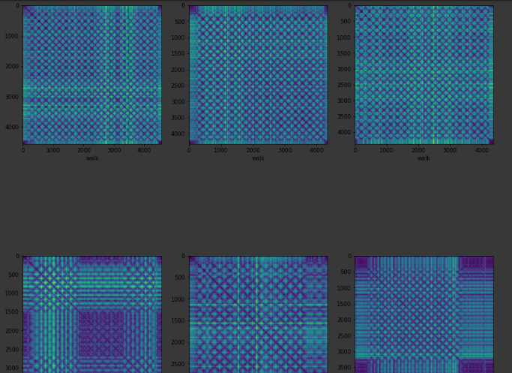

Danger Recurrence plot for the time series Data (see below)

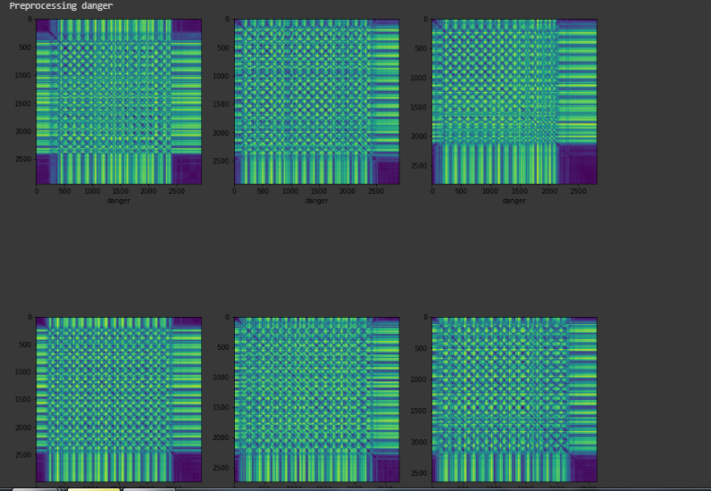

Jogg plots(see plots below)

